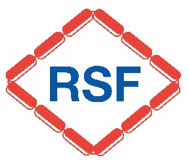
Applications are invited for the position of
Shift Maintenance Operative
Attractive Salary & Benefits, based in Ripon
Established in 1974, Ripon Select Foods Ltd is a family-owned business manufacturing dry food ingredients used in many leading branded products. We aim to offer job satisfaction and security. We are looking for a dynamic and highly motivated Engineer to join our maintenance team.
- Working 40 hours per week on a 3-shift rota, the work involves planned and unplanned maintenance, plant lubrication, plus other routine tasks and ad hoc duties as they arise.
- The successful applicant will be positive, reliable and responsible, with transferable engineering skills including knowledge of industrial plant and plant maintenance.
- Part of a dedicated engineering team, your role will be to support the production process.
Benefits include competitive salary, contributory pension scheme, workwear and generous holiday allowance.
To apply, application packs are available by:
- Download from our website: www.rsf.co.uk
- Email: ingredients@rsf.co.uk
- Write to: The H&S and HR Manager, Ripon Select Foods Limited, Dallamires Way North, Ripon, North Yorkshire, HG4 1TL

No closing date.

